[Enterprise JavaScript Error Handling](https://www.slideshare.net/nzakas/enterprise-javascript-error-handling-presentation/)

1. **Assume your code will fail**

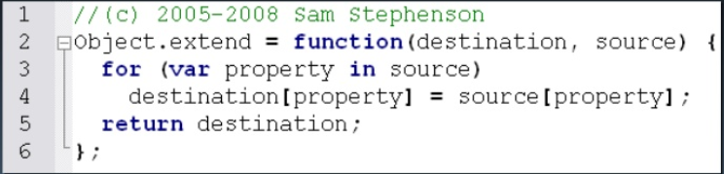

* What if the destination is null?
* What if the source is null?

1. **Log errors to the server**

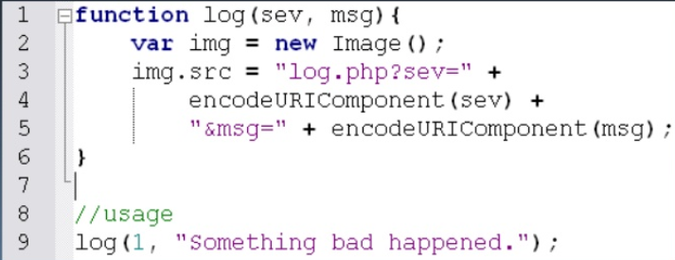

1. **You, not the browser, handle errors**

* **Try – catch**

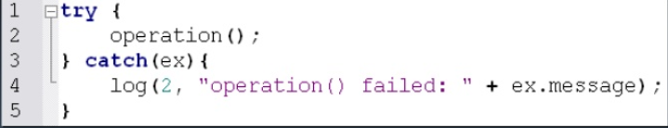

* **Thrown errors contain extra information.**
* **Errors that are caught are considered to have been handled.**
* **Window.onerror**

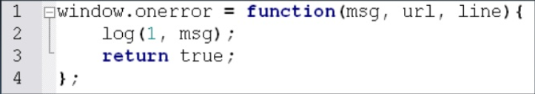

* **Last stops before browser responds**
* **Return true to indicate not to respond**
* **Only supported in Internet Explorer and Firefox**

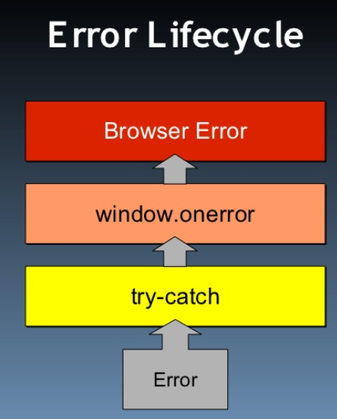

1. **Identify where errors might occur**

* **Types of errors**
* **Type coercion errors**
* **Data type errors**
* **Communication errors**
* **Invalid URL/post data**
* **Server response status**
* **No network connection**
* **Server response content**

1. **Throw your own errors**

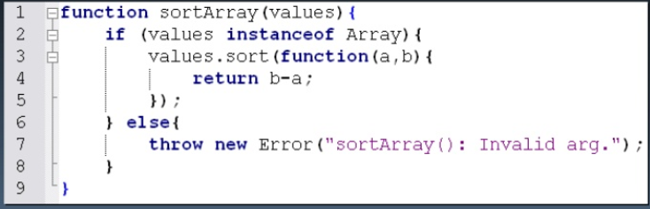

* **Throw or Try-Catch**
* **Errors should be thrown in the low-level parts of the application (utilities, core libraries, etc).**
* **Use try-catch blocks in higher level parts (application specific or client side business logic).**

1. **Distinguish fatal versus non-fatal errors**

* **Non Fatal errors**
* **Won’t interfere with user’s main tasks**
* **Affects only a portion of the page and can be easily disabled/ignored**
* **Recovery is possible**
* **A repeat of the action may result in the appropriate results**
* **Don’t tell the user it isn’t working unless absolutely necessary.**
* **Fatal errors**
* **The application absolutely cannot continue**
* **Significantly interferes with user’s ability to be productive**
* **Other errors will occur if the application continues.**
* **Message the user immediately**
* **Reload.**

1. **Provide a debug mode**

* **Debug mode**
* **Assign a variable that is globally available.**
* **Try-catch should re-throw the error**
* **Window.onerror should return false**
* **Allow the browser to handle the error.**

